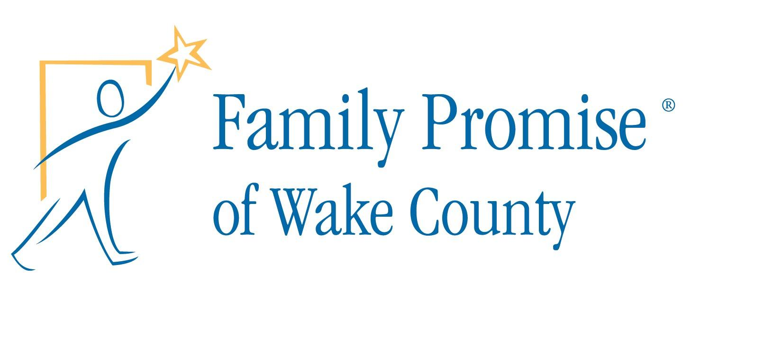

Authorization and Release for Photos, Audio/Video Recording
Night in a Car – Date

Name:________________________________________________________________

Child’s Name (s):_______________________________________________________

Address:_______________________________________________________________

Phone:________________________Email:___________________________________

Family Promise of Wake County and Name of Church routinely take photographs or make audio or video recordings (images) of participants in Family Promise and Name of Church events and activities. There are often times when Family Promise and/or Name of Church would like to use the images in reports, presentations, and/or publicity/promotion for the organizations. We would like to be able to use your/your child’s images for these purposes, so we are asking each participant to complete this authorization and release form.

Please complete only one:

I, __________________________________________, individually, and if applicable, the parent or legal guardian of the above child, hereby GRANT Family Promise of Wake County and Church Name, the right, without fee, to make edit, use, or display photos and audio/video recordings (images) of me and my child. I agree that the images may be used in any form of written or electronic media now existing or created in the future, including standard print, websites, CD or DVD. I understand that the images will be externally released, but will only be used for news or publicity purposes to benefit Family Promise and Name of Church and will not be used for the profit of any individual or other corporation. I further understand that my/my child’s images will not be identified by name without further consent.

I, __________________________________________, DO NOT give my permission to Family Promise to use my/my child’s images for any news or publicity purpose.

Signature/Parent Signature:__________________________________Date:_________

Print Name:____________________________________________________________

